Creating A new Database and company and importing basic data in business central

1. Open dynamics nav development environment and create a new db

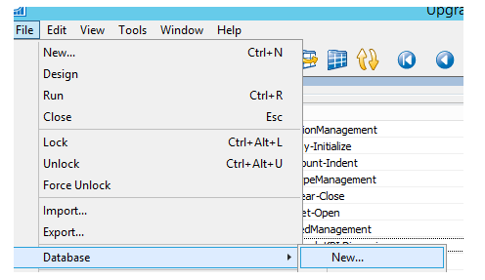

1. Open SSMS and backup the old db

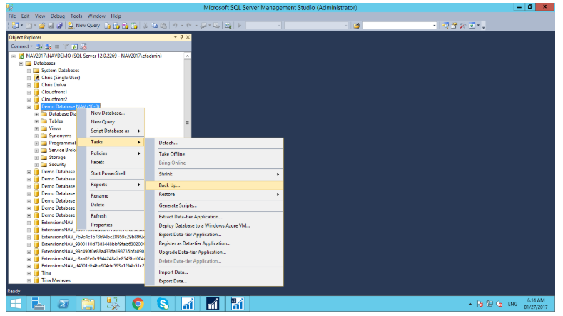

1. Restore the new db with back

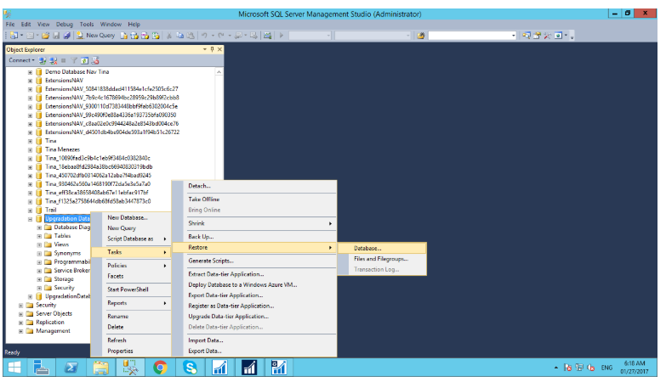

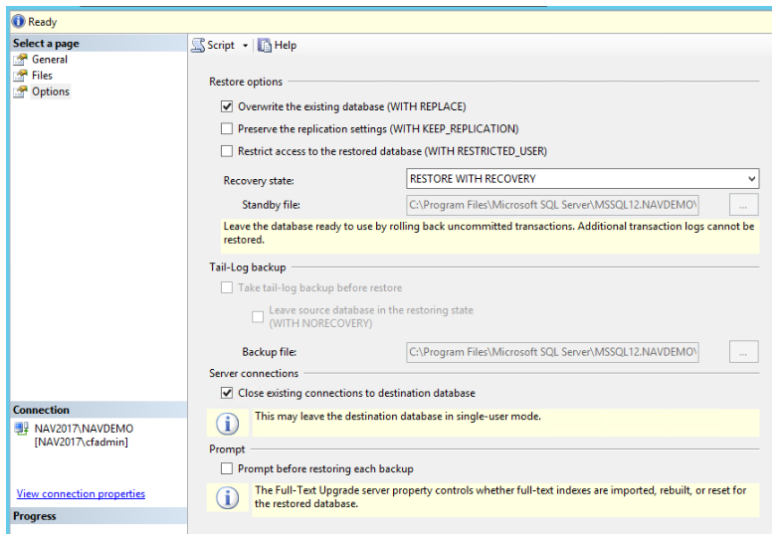

1. In the Microsoft dynamics NAV Administrator, right click on the Microsoft dynamics NAV(Local) and select Add Instance. Here Specify the Server Instance name and enter the unique port numbers and click on OK. This creates the server instance.

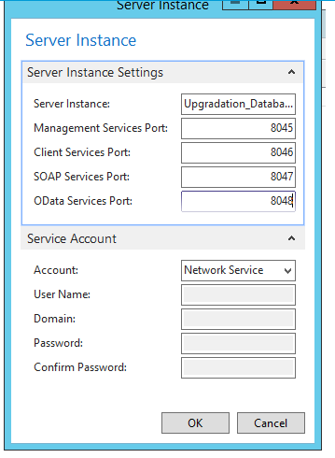

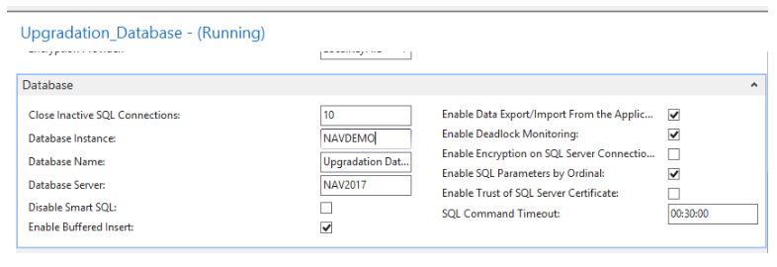

1. Open Dynamics Nav client, connect with new db instance, create new company.
2. Open backup company instance and in search type rapid start service.
3. Export the default package in excel.

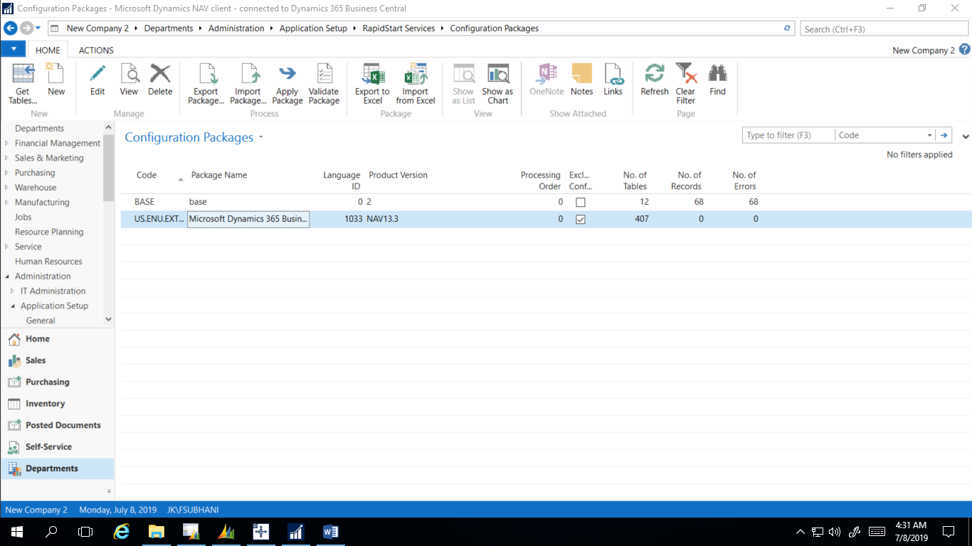

1. Open new company instance and import the saved package